37.74: a) The speed 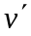is measured relative to the rocket, and so for the rocket and its occupant, 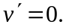 The acceleration as seen in the rocket is given to be 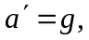 and so the acceleration as measured on the earth is
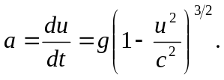
b) With 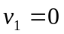 when ,
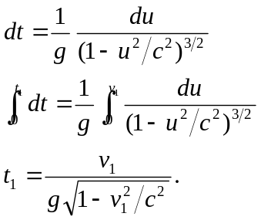
c) 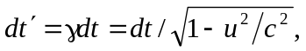so the relation in part (b) between dt and du, expressed in terms of 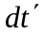and du, is
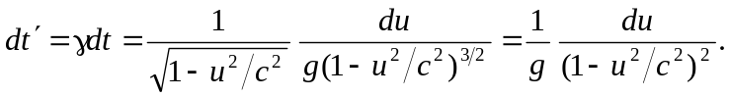
Integrating as above (perhaps using the substitution 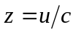) gives
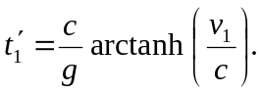
For those who wish to avoid inverse hyperbolic functions, the above integral may be done by the method of partial fractions;
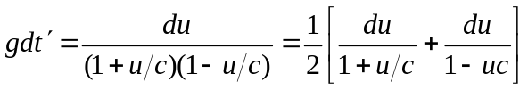,
which integrates to
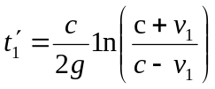.
d) Solving the expression from part (c) for 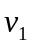in terms of 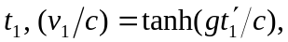 so that 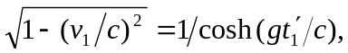using the appropriate indentities for hyperbolic functions. Using this in the expression found in part (b),
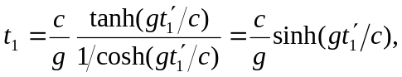
which may be rearranged slightly as
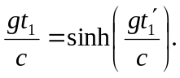
If hyperbolic functions are not used, in terms of is found to be
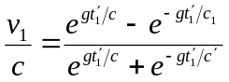
which is the same as tanh(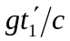). Inserting this expression into the result of part (b) gives, after much algebra,
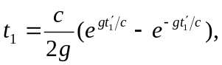
which is equivalent to the expression found using hyperbolic functions.
e) After the first acceleration period (of 5 years by Stella’s clock), the elapsed time on earth is
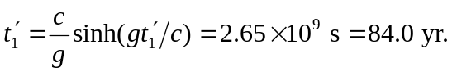
The elapsed time will be the same for each of the four parts of the voyage, so when Stella has returned, Terra has aged 336 yr and the year is 2436. (Keeping more precision than is given in the problem gives February 7 of that year.)

